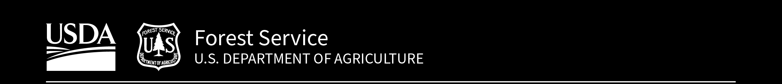

Carson National Forest

# Forest Service News Release

Zach Behrens

(575) 758-6303

[zachary.behrens@usda.gov](mailto:zachary.behrens@usda.gov)

[fs.usda.gov/carson](https://www.fs.usda.gov/carson/)

### **Prescribed Fire Planned for Forest, Private Property**

### Fire Will Cross Onto Ted Turner’s Vermejo Reserve

**Taos, N.M., Oct. 23, 2024**—After evaluating post-storm site conditions, fire managers for the Carson National Forest and the privately-owned [Vermejo Reserve](https://tedturnerreserves.com/vermejo/) plan to begin ignitions on a cross-boundary prescribed fire as early as Friday, Oct. 25.

“This is a ground-breaking project for the Carson National Forest,” said Questa District Ranger Amy Simms. “Fire knows no boundaries, so it’s important that we work with partners and private property owners to address the wildfire threat based on the realities of the landscape, not administrative lines.”

It is a long-term goal that “fire functions in its natural ecological role on a landscape scale and across administrative boundaries,” according to the [Carson National Forest Land Management Plan](https://www.fs.usda.gov/Internet/FSE_DOCUMENTS/fseprd1040268.pdf).

The North Hart Prescribed Fire will be the first time the Carson National Forest has used a congressionally authorized tool known as a Wyden Agreement to conduct restoration work collaboratively across boundaries. Additionally, a qualified Vermejo Reserve wildland fire employee will assist the burn boss, who will manage the prescribed fire, in a training role.

The 1,871-acre unit is about evenly split between Forest Service and Vermejo Reserve lands. Ignitions are expected to take two days. Once completed, the work will connect with over 22,000 contiguous acres that have been treated with prescribed fire over the past seven years in the Valle Vidal, which is often referred to as “The Yellowstone of the Southwest.”

**Quick Facts**

* The prescribed fire unit is located on the northeastern corner of Valle Vidal, partially bounded by a portion of Forest Road 1950 and Forest Road 1915. A map that features this fall’s three potential prescribed fires in the Valle Vidal is [available online](https://www.fs.usda.gov/Internet/FSE_DOCUMENTS/fseprd1208360.pdf).
* There are no planned road closures, although traffic may temporarily be stopped.
* Smoke is forecasted to push out of the Valle Vidal during daytime ignitions, but residual smoke may lay down in the valley overnight.
* Updates will be available on [InciWeb](https://inciweb.wildfire.gov/incident-information/nmcaf-north-hart-prescribed-fire) and [by other means](https://www.fs.usda.gov/detail/carson/fire/?cid=fseprd1205806). The public can learn more about prescribed fires on the Carson National Forest at [fs.usda.gov/goto/CarsonRx](https://www.fs.usda.gov/goto/CarsonRx).
* The previously announced [Powderhouse Prescribed Fire](https://inciweb.wildfire.gov/incident-information/nmcaf-powderhouse-prescribed-fire) on the western end of Valle Vidal remains on hold due to site conditions (too much moisture).